Flamenco Dance Workshop
with
Juan Del Valle
December 2-4 2005

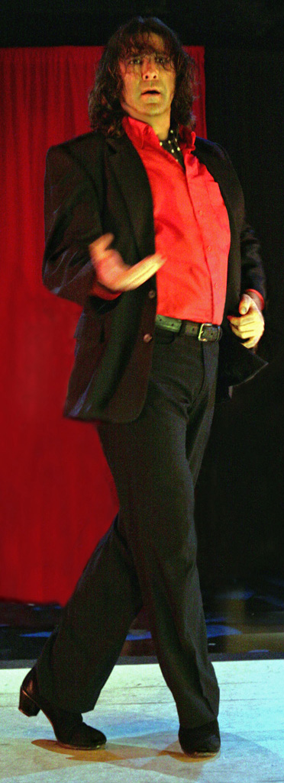
photo: Bruce Bisenz, Hollywood
“Juan Del Valle’s strong shoulders and penetrating glance gave his solo alegria energy and power. Dancers…riveting….”
Craig Smith
The Santa Fe New Mexican

Juan recently completed ten weeks of summer performances as a soloist with the company of Maria Benitez, Teatro Flamenco, where he worked with leading flamenco artists including Antonio Granjero and famed gipsy guitarist Chuscales. Juan is now teaching flamenco dance at the Institute for Spanish Arts in Santa Fe, New Mexico and performing internationally. He just returned from Venezuela where he was hosted by the University of Zulia and the national Ministry of Culture to participate in the International Dance Congress, Cuerpo Creativo, which included a nationally televised performance and a week of master classes. In March of 2004, Juan was selected to dance in the premier performance of Israel Galvan’s Torero al Lucinogen at the Teatro Central in Sevilla, Spain. Concurrently, he performed a five-month run as a soloist at La Carboneria in Sevilla with shows televised in New York and Europe. Juan has also travelled as a guest of the Chinese government to perform in the internationally televised Culture Festival of Beijing. He has performed throughout the United States with companies including Romeria Flamenca of New York, Jose Porcel Company from Madrid, Spain, Caminos Flamencos of San Francisco and as a featured artist at the Fountain Theater in Hollywood.

$20 per class $100 for entire workshop

Beg & Int Tangos (of Spain)

Friday 6-7pm
Saturday 3:30-4:30pm
Sunday 2:30-3:30pm

Theater On The Run
3700 Four Mile Run Drive
Arlington, Virginia

Int & Adv Bulerias

Friday 7-8pm
Saturday 4:30-5:30pm
Sunday 3:30-4:30pm

For questions, contact Juan at 415-517-7477

